**Devops – Final Assessment**

**Section 1: Multiple-Choice Questions (MCQs)**

1. What does WSL stand for in the context of Windows?

Answer: c. Windows Subsystem for Linux

Reason: WSL, or Windows Subsystem for Linux, is a compatibility layer in Windows that allows running Linux applications natively. It stands for Windows Subsystem for Linux.

2. What is the primary goal of continuous integration (CI) in DevOps?

Answer: b. Frequent integration of code changes

Reason: The primary goal of continuous integration (CI) is to frequently integrate code changes into a shared repository, ensuring that code changes from multiple developers are integrated and tested as often as possible.

3. In the Linux command line, what does the cd command do?

Answer: b. Change the working directory

Reason: The "cd" command in the Linux command line is used to change the current working directory, allowing you to navigate the file system.

4. Which of the following is not a Linux distribution?

Answer: c. Docker

Reason: Docker is not a Linux distribution; it is a platform for containerization and application deployment. Linux distributions include Ubuntu, CentOS, Debian, and others.

5. What is Docker primarily used for in DevOps and containerization?

Answer: c. Packaging and deploying applications in containers

Reason: Docker is primarily used for packaging applications and their dependencies into containers, making it easier to deploy, manage, and scale applications in a consistent and isolated environment.

6. What is the primary purpose of Azure DevOps?

Answer: b. Software development and delivery

Reason: Azure DevOps is a set of DevOps tools and services provided by Microsoft for software development and delivery. Its primary purpose is to support the entire software development lifecycle, including planning, coding, building, testing, and delivery.

7. Which components are part of Azure DevOps?

Answer: c. Azure Boards and Azure Pipelines

Reason: Azure DevOps consists of several components, including Azure Boards for work item tracking and Azure Pipelines for continuous integration and continuous delivery (CI/CD). These are two of the key components.

8. How does Azure DevOps support version control in software development?

Answer: b. It tracks changes in source code and manages versions.

Reason: Azure DevOps includes version control tools (e.g., Azure Repos) that track changes in source code, manage versions, and facilitate collaborative development by multiple team members.

9. In Linux, what is the primary role of the root user?

Answer: c. administrative tasks with superuser privileges

Reason: The root user in Linux has superuser privileges and is responsible for performing administrative tasks, managing the system, and making system-wide changes.

10. In Azure DevOps, which component is used to define, build, test, and deploy applications?

Answer: c. Azure Pipelines

Reason: Azure Pipelines is used to define, build, test, and deploy applications in a continuous integration and continuous delivery (CI/CD) pipeline, making it an essential component for software development and deployment in Azure DevOps.

**Section 2: Labs**

Lab 1: File and Directory Management

Objective: Practice basic file and directory management commands.

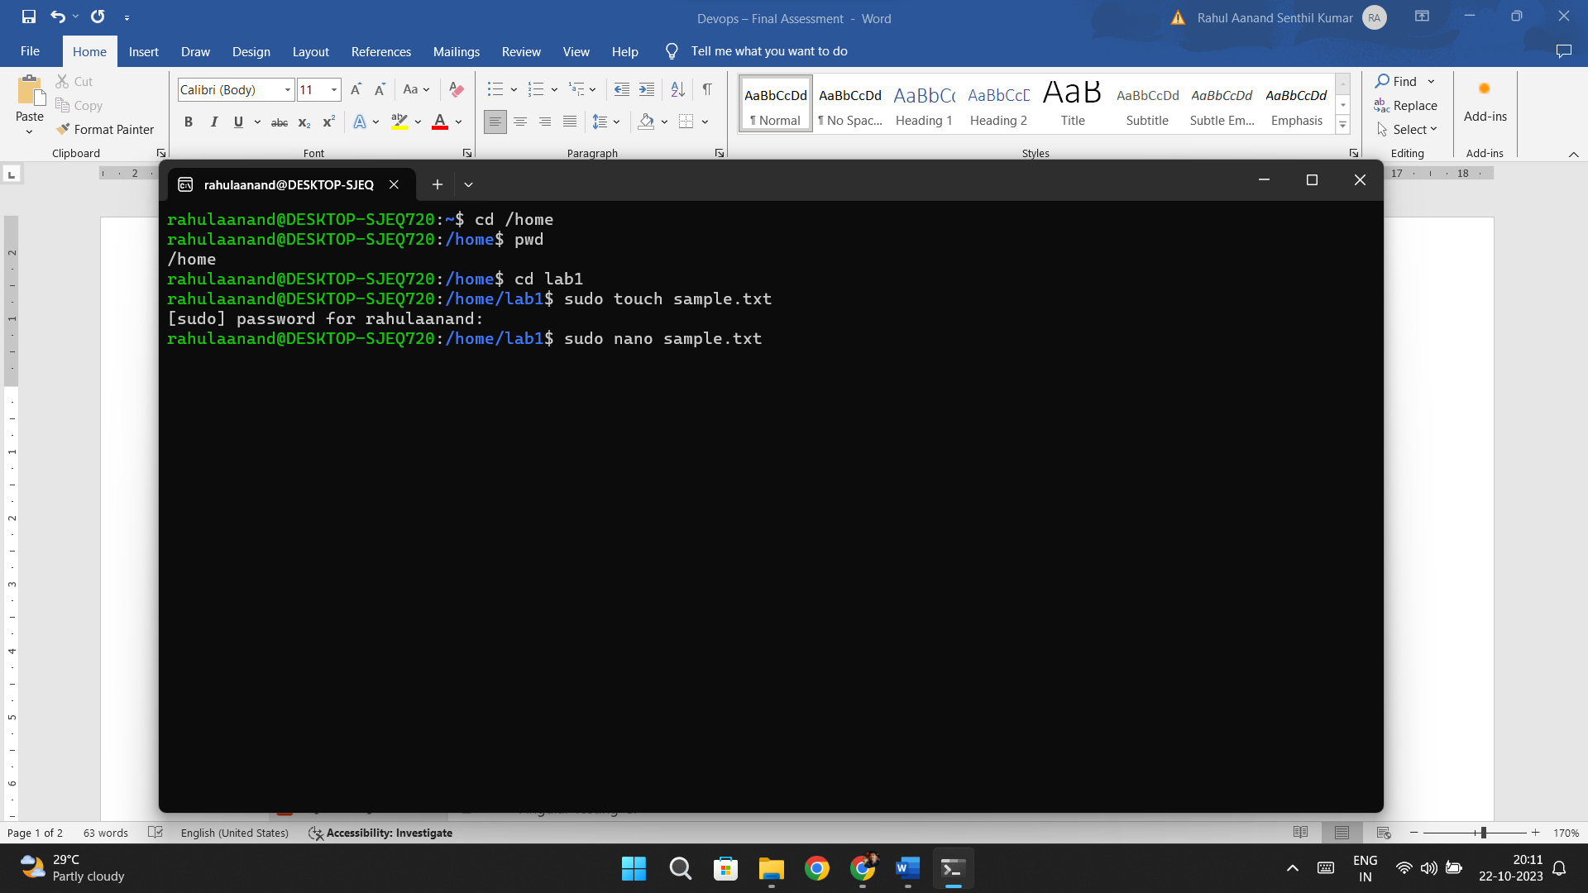

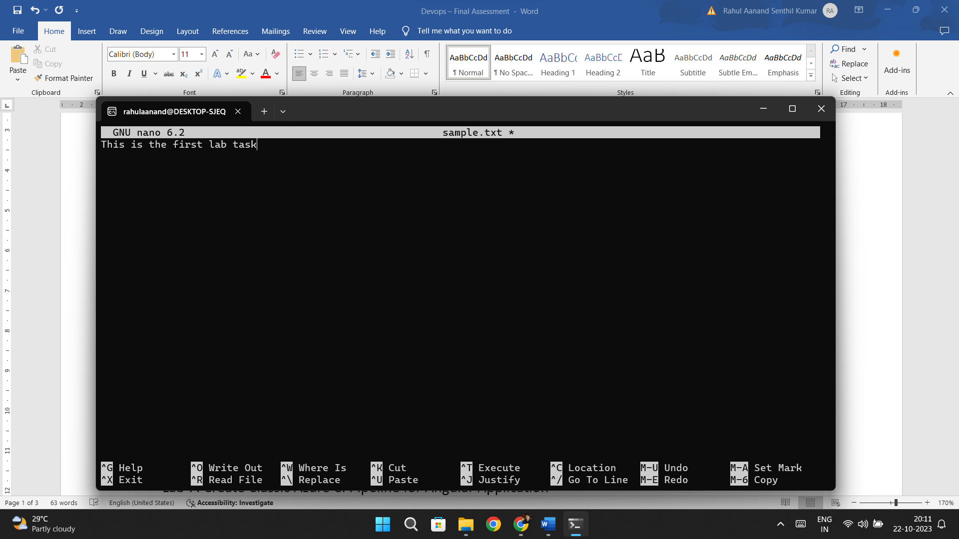

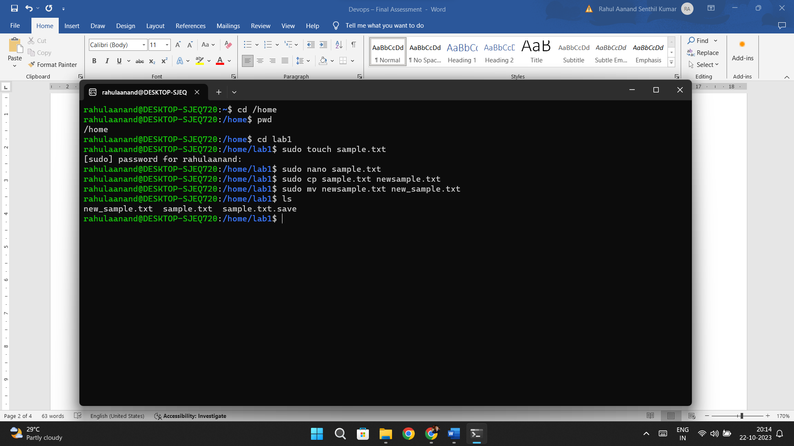

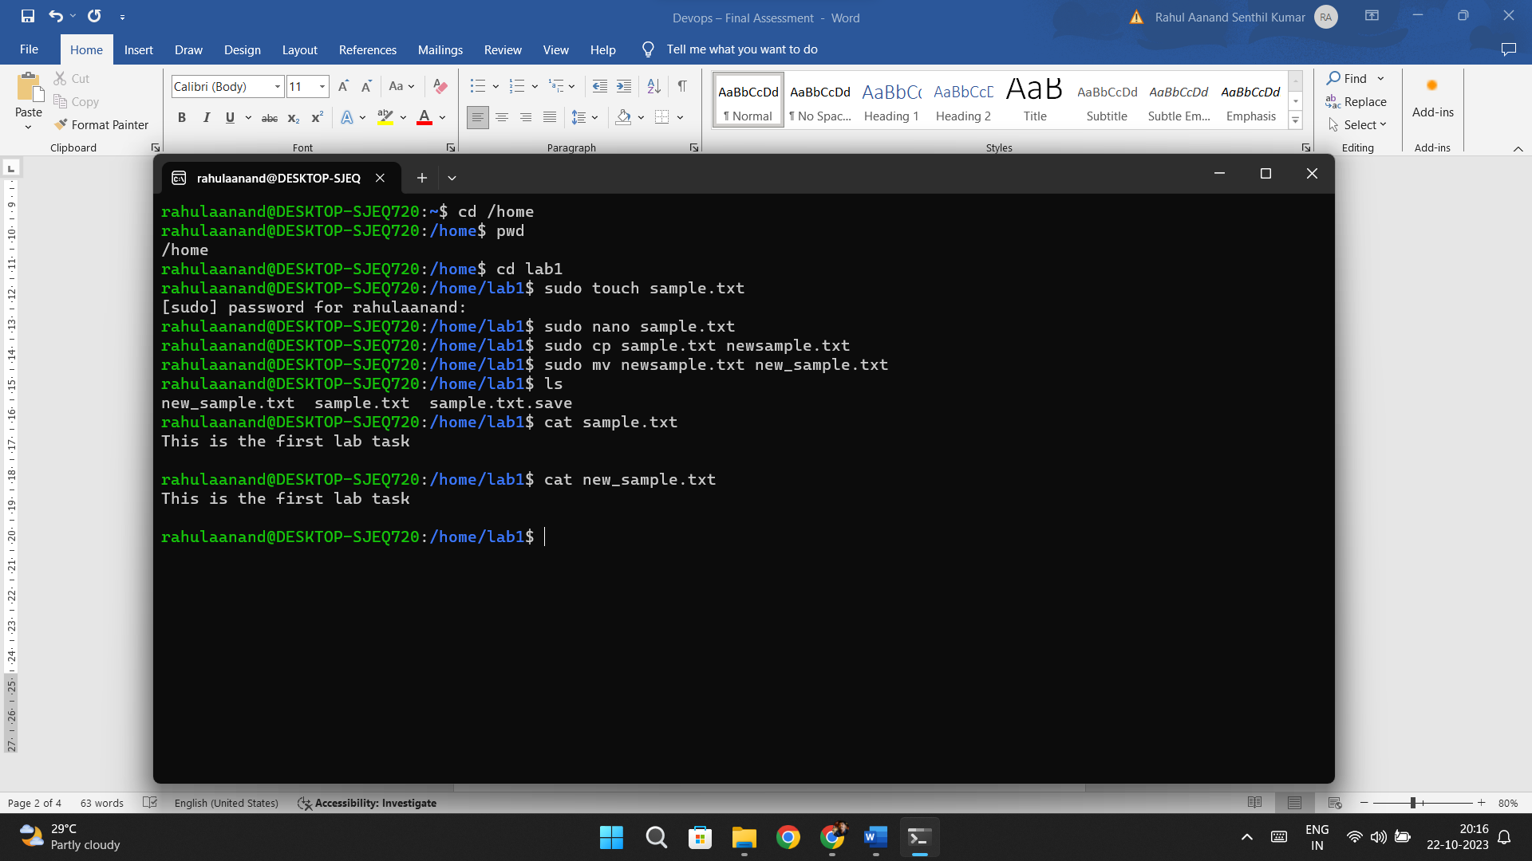

Lab 2: Permissions and Ownership

Objective: Understand and manage file permissions and ownership.

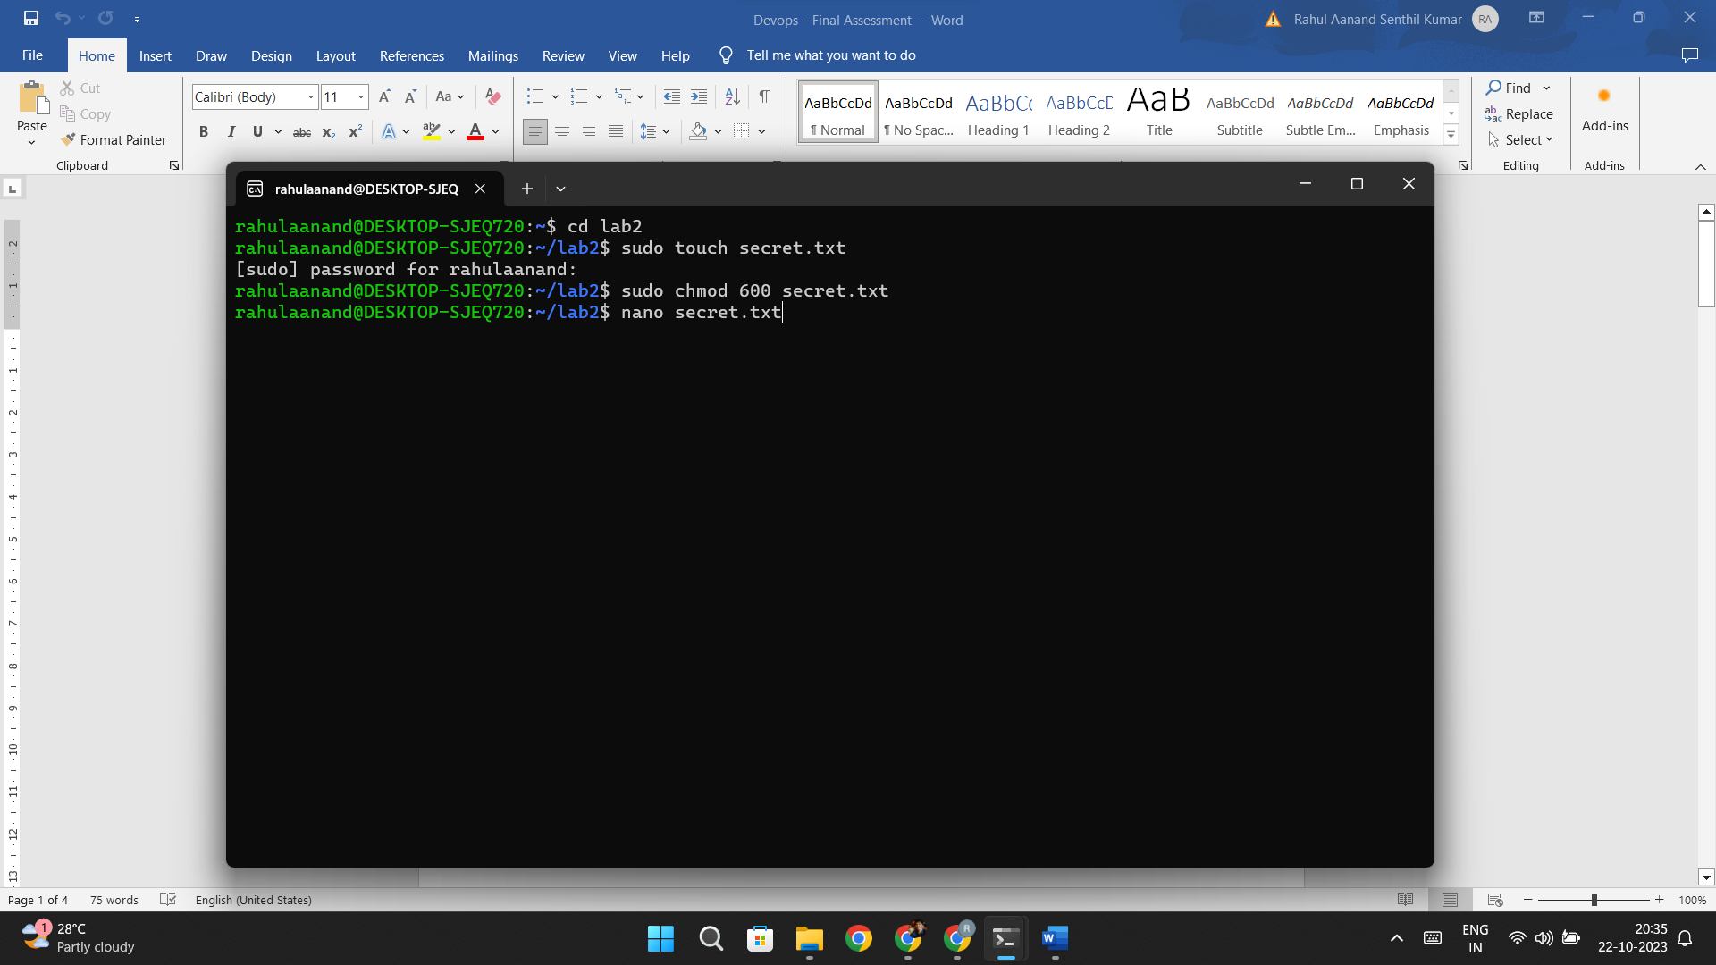

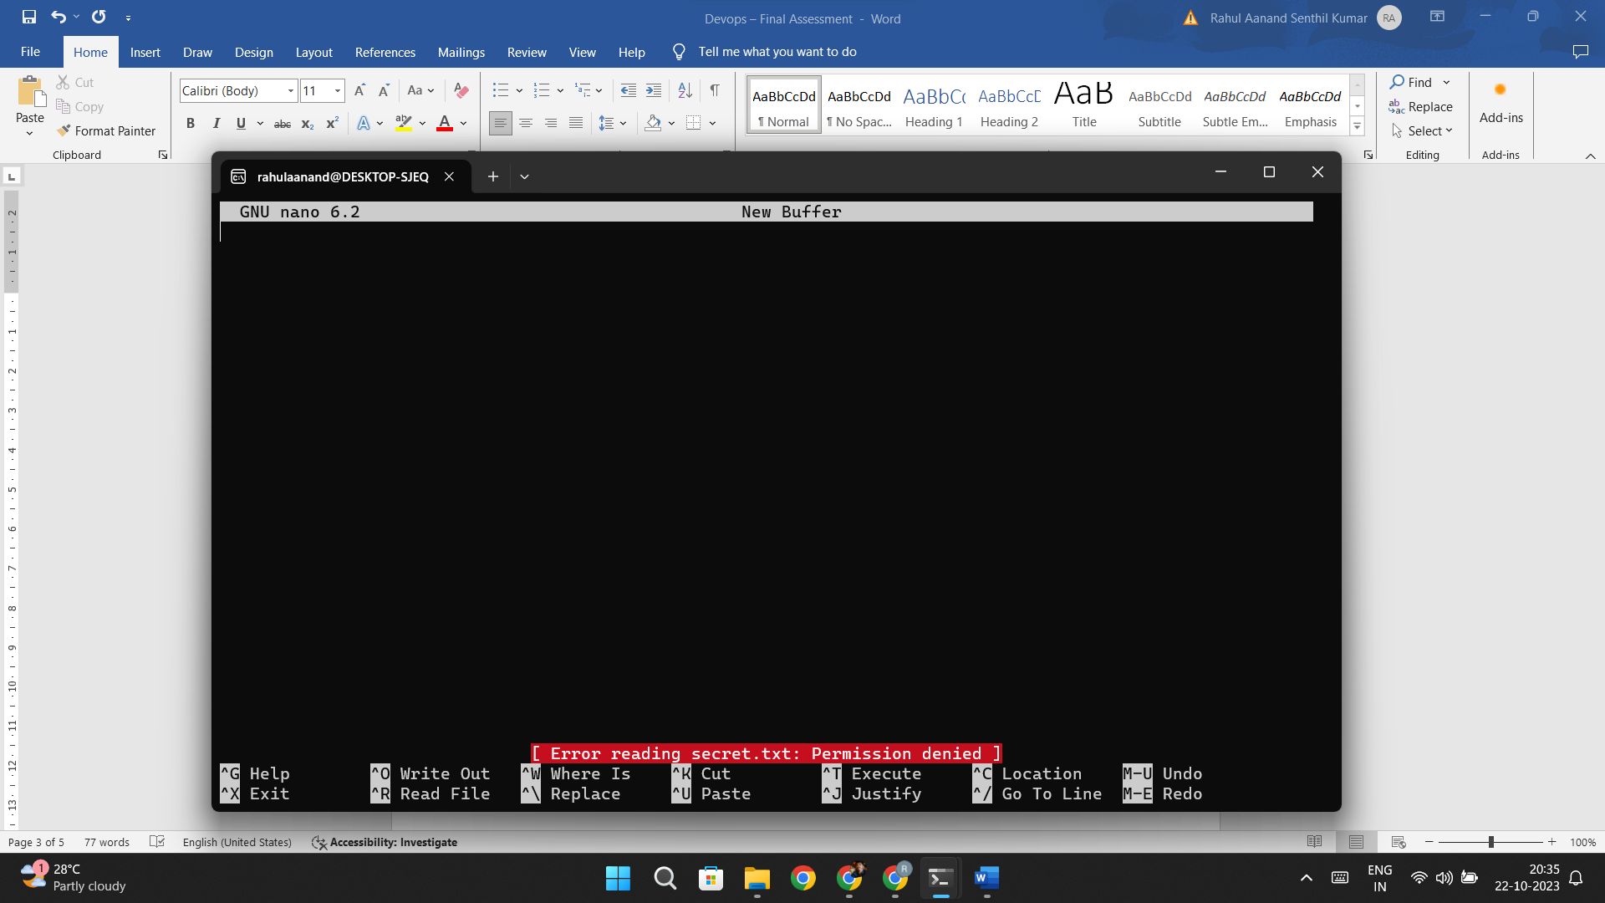

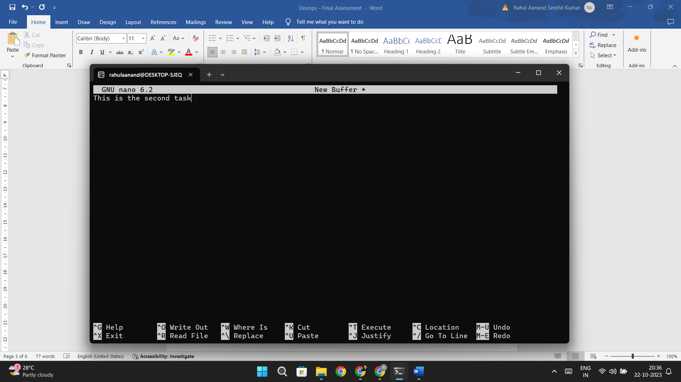

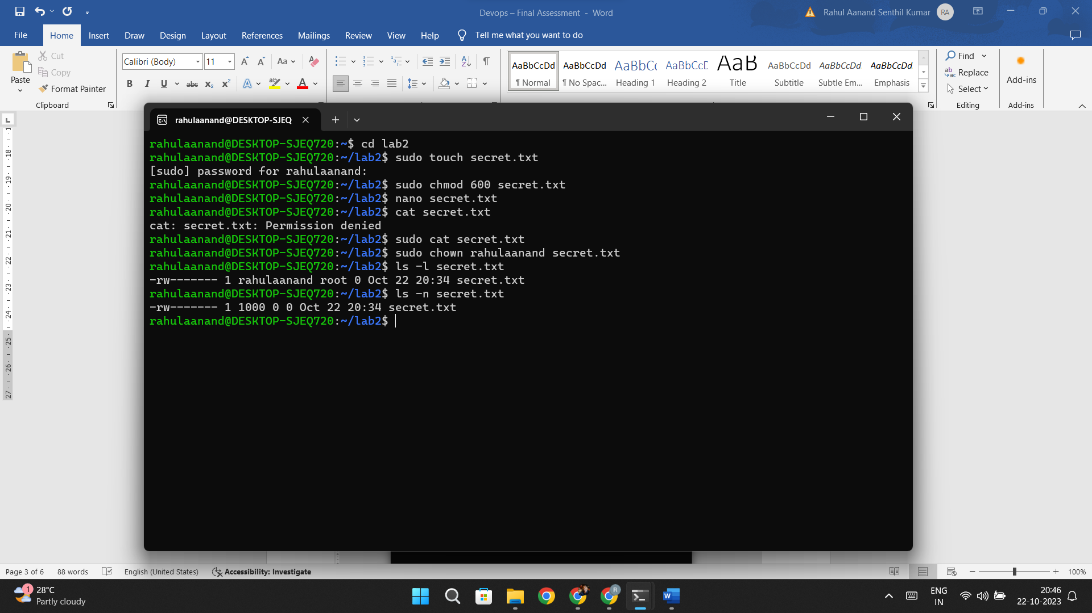

Lab 3: Text Processing with Command Line Tools

Objective: Practice text processing using command-line tools.

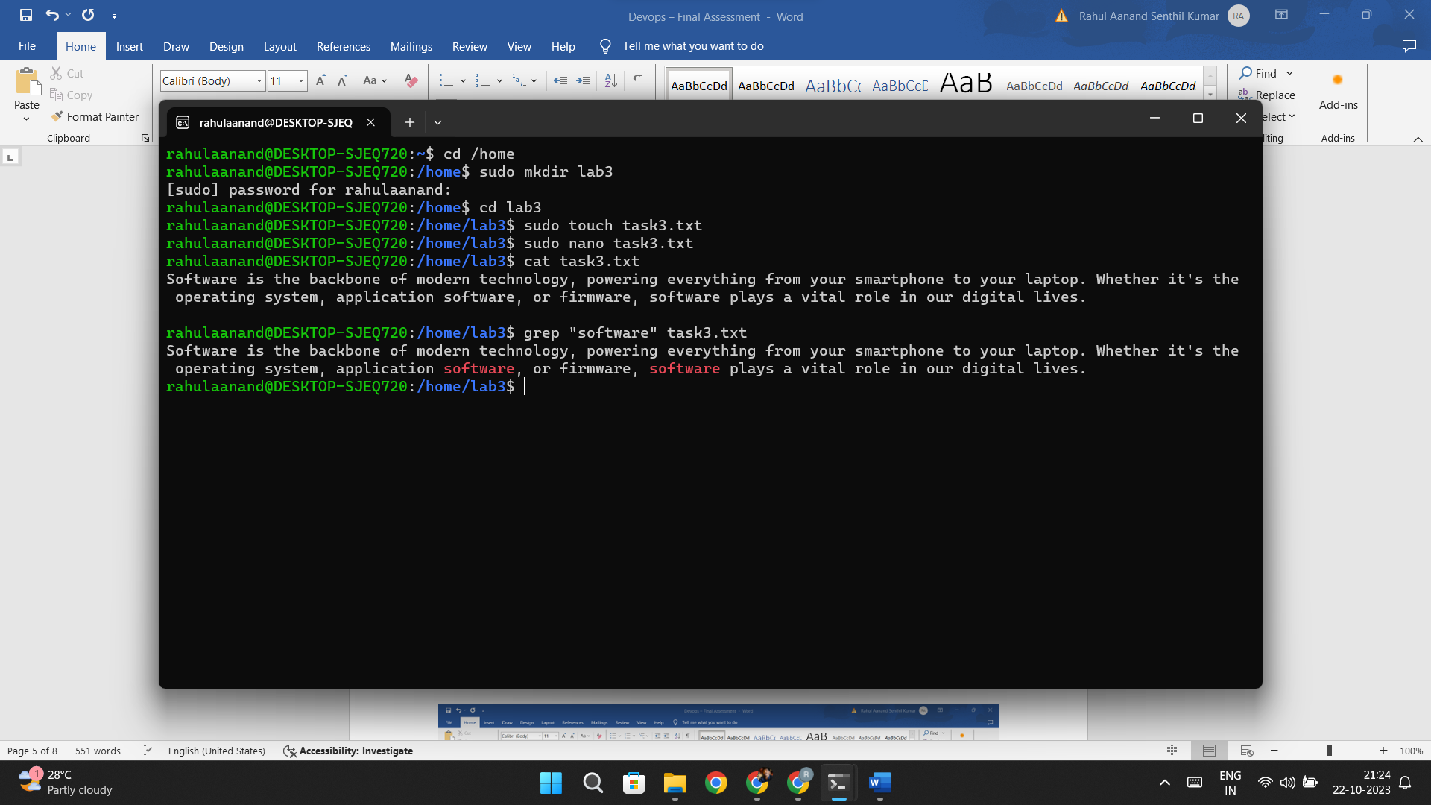

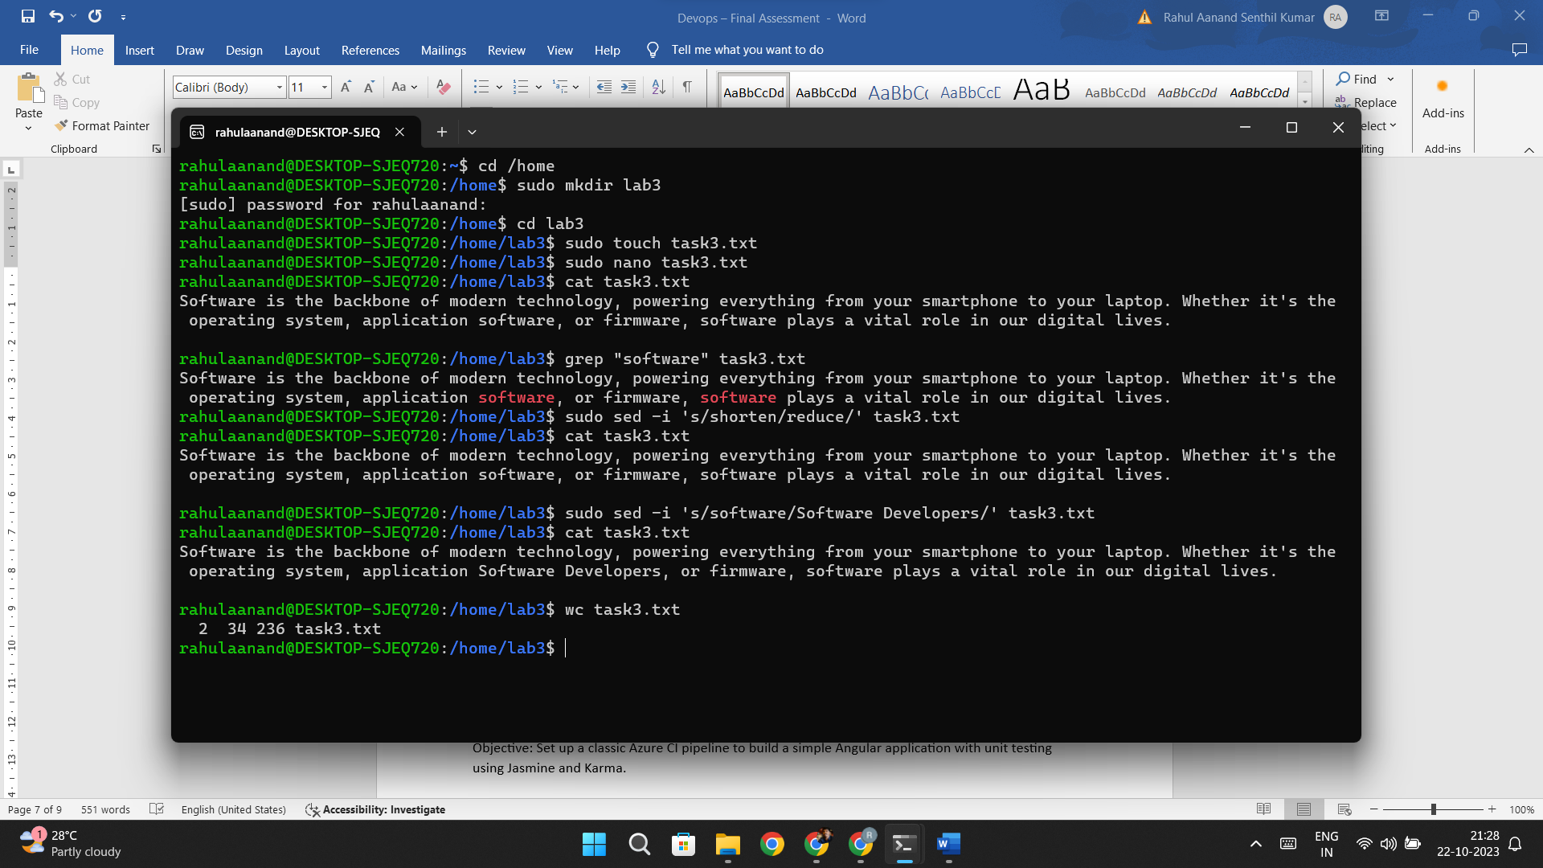

Lab 4: Creating a Simple YAML File

Objective: Create a basic YAML configuration file.

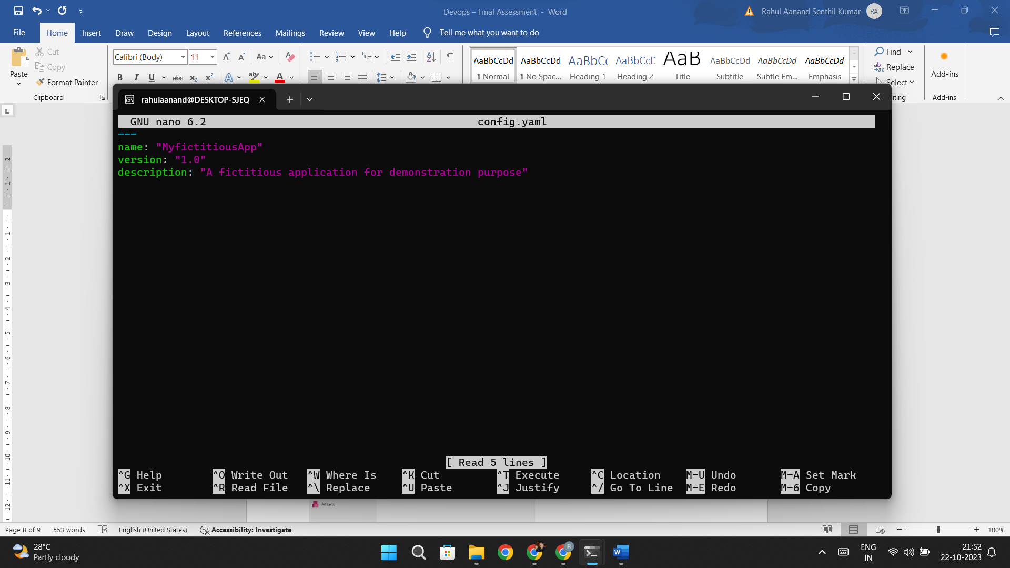

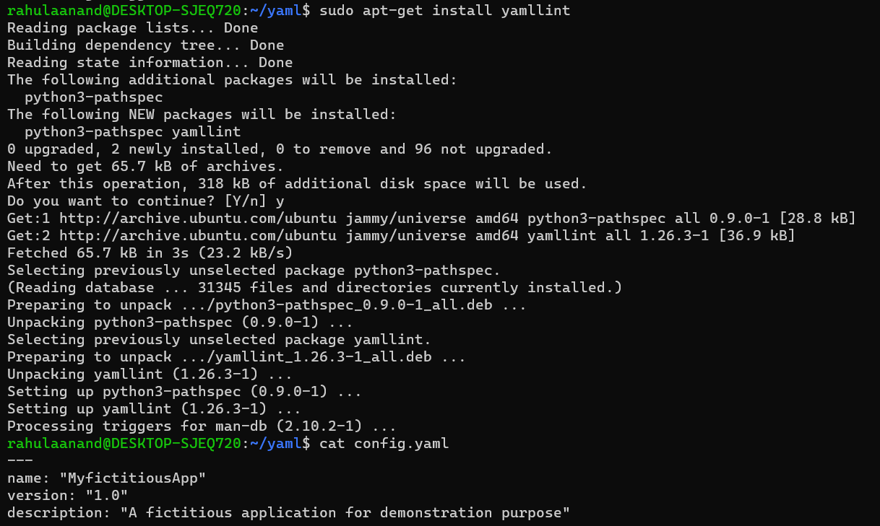

With error:

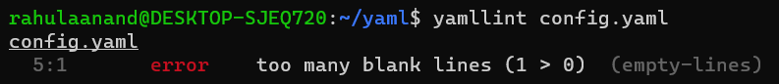

Without error:



Lab 5: Working with Lists in YAML

Objective: Practice working with lists (arrays) in YAML.

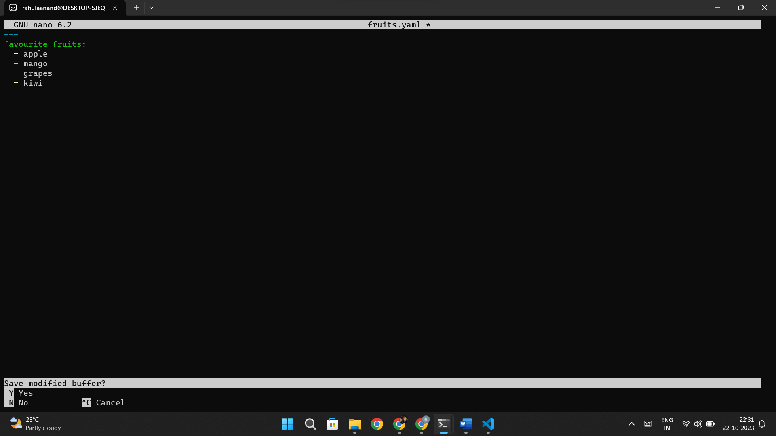

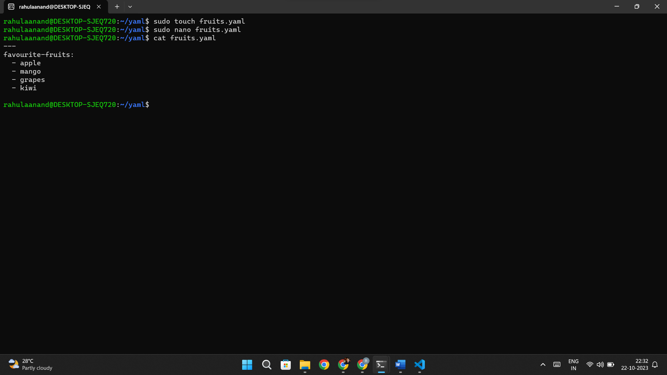

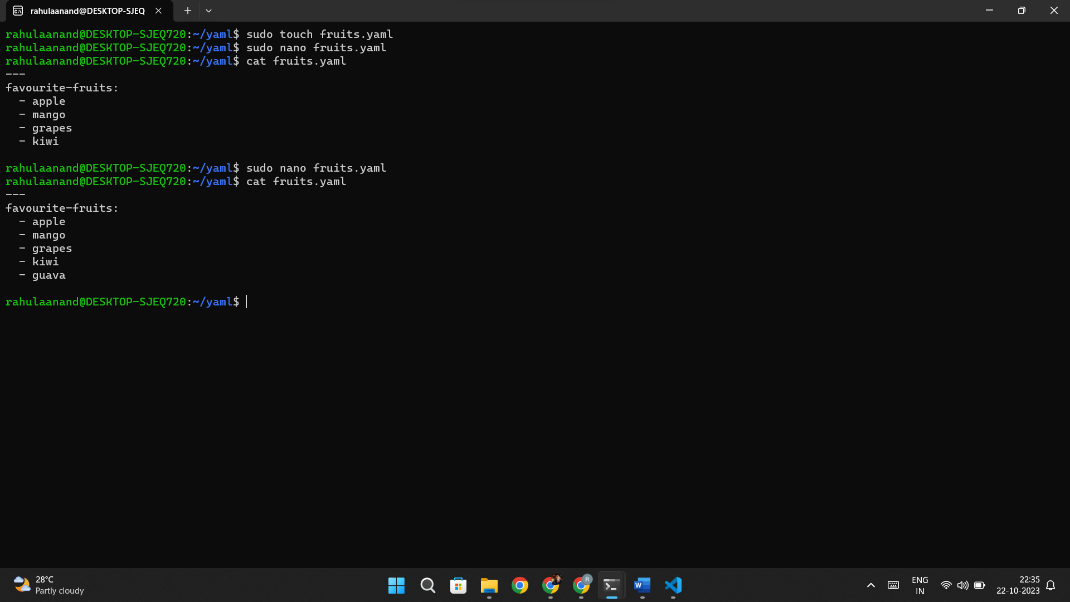

Lab 6: Nested Structures in YAML

Objective: Explore nested structures within YAML.

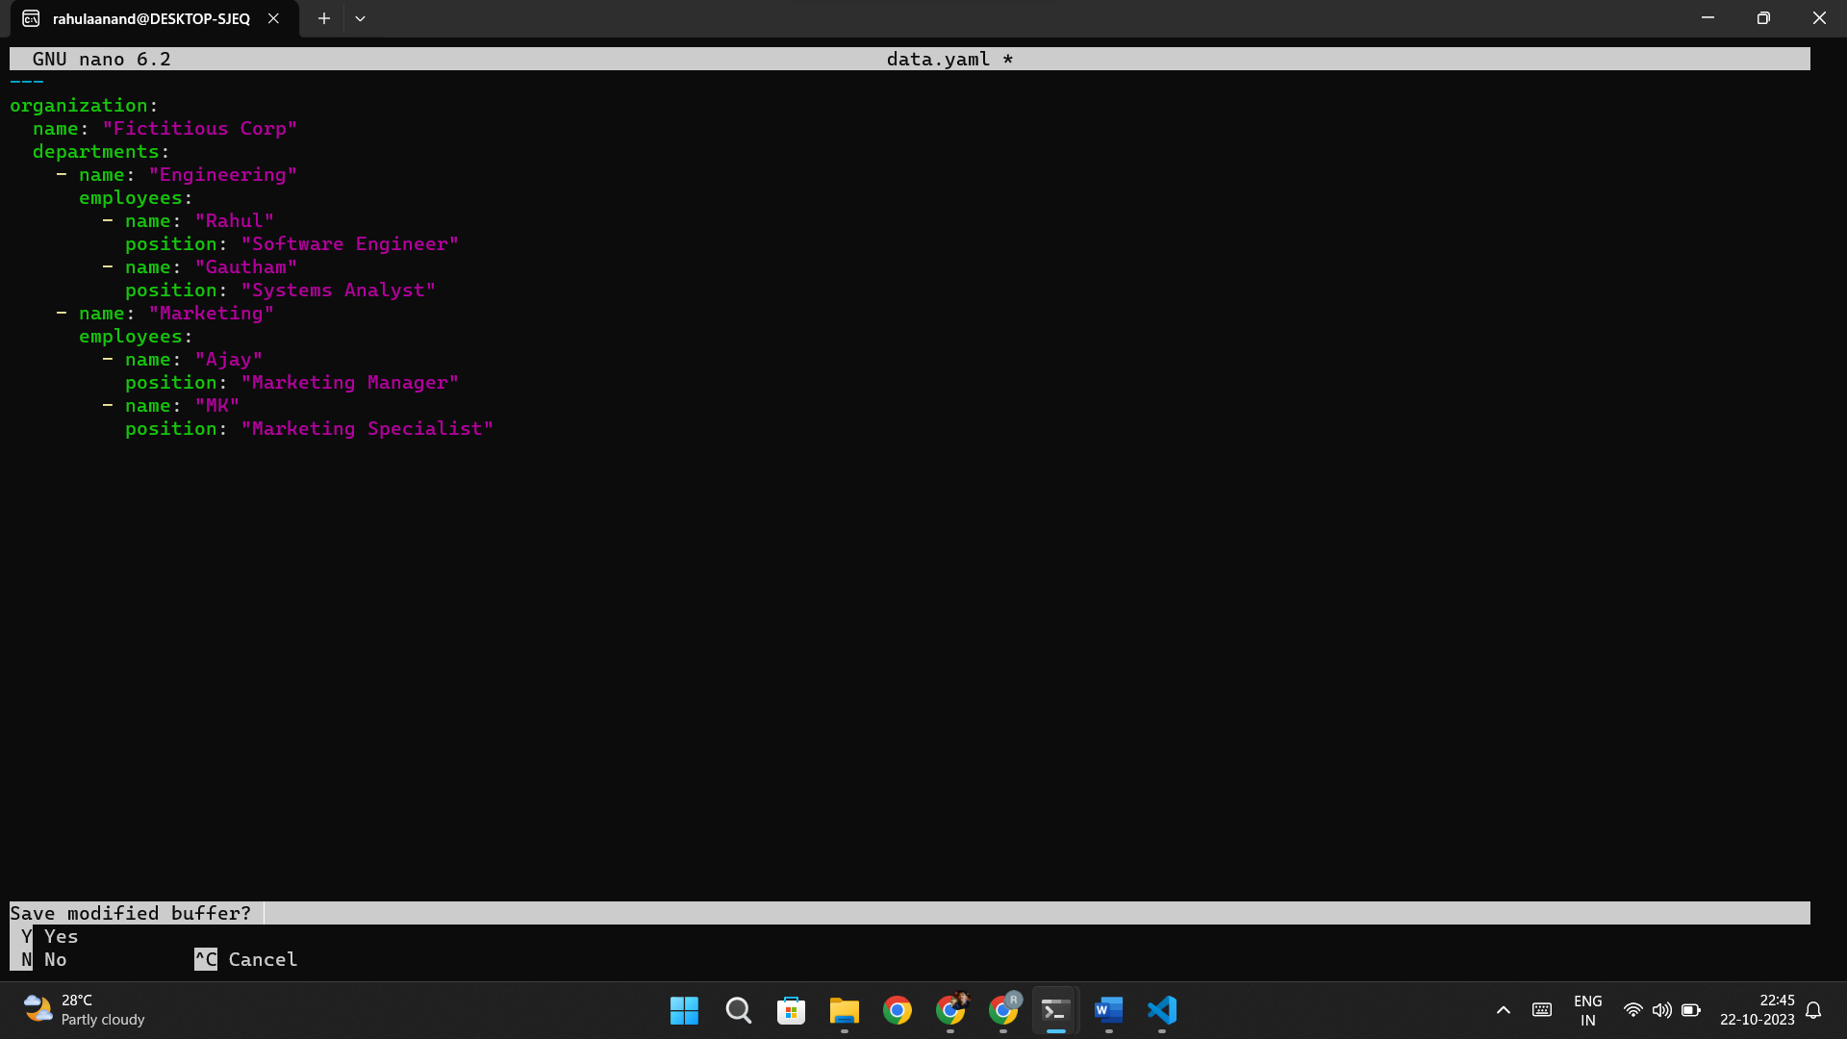

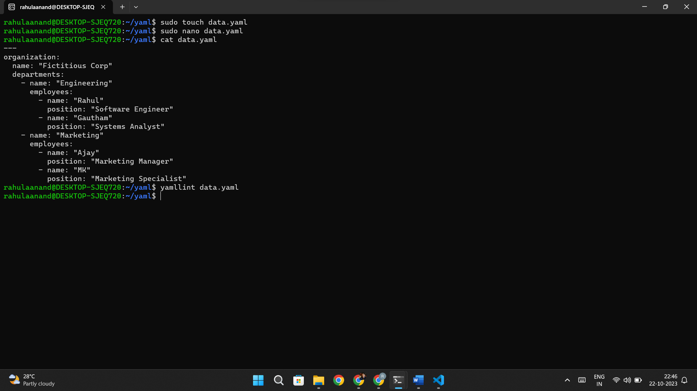

Lab 7: Create Classic Azure CI Pipeline for Angular Application

Objective: Set up a classic Azure CI pipeline to build a simple Angular application with unit testing using Jasmine and Karma.

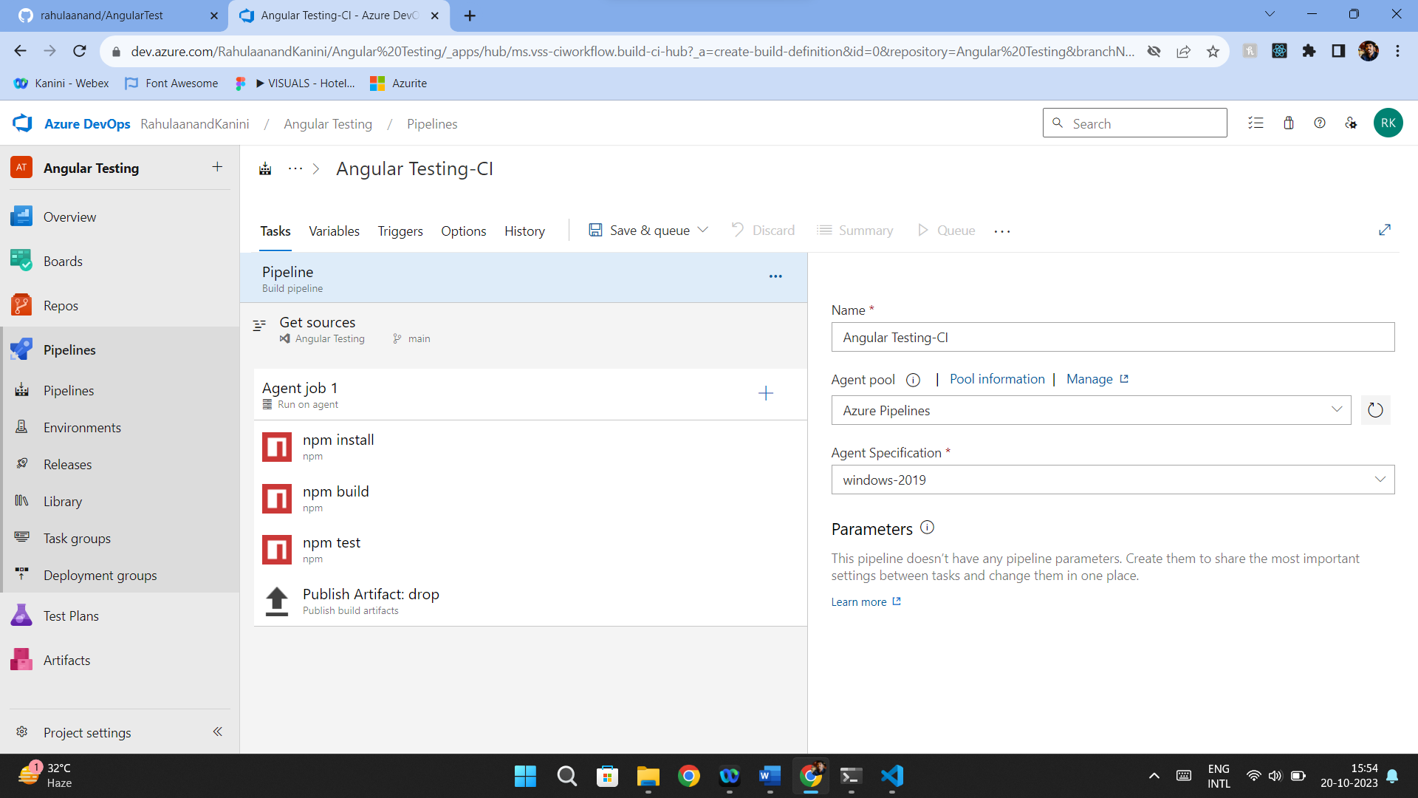

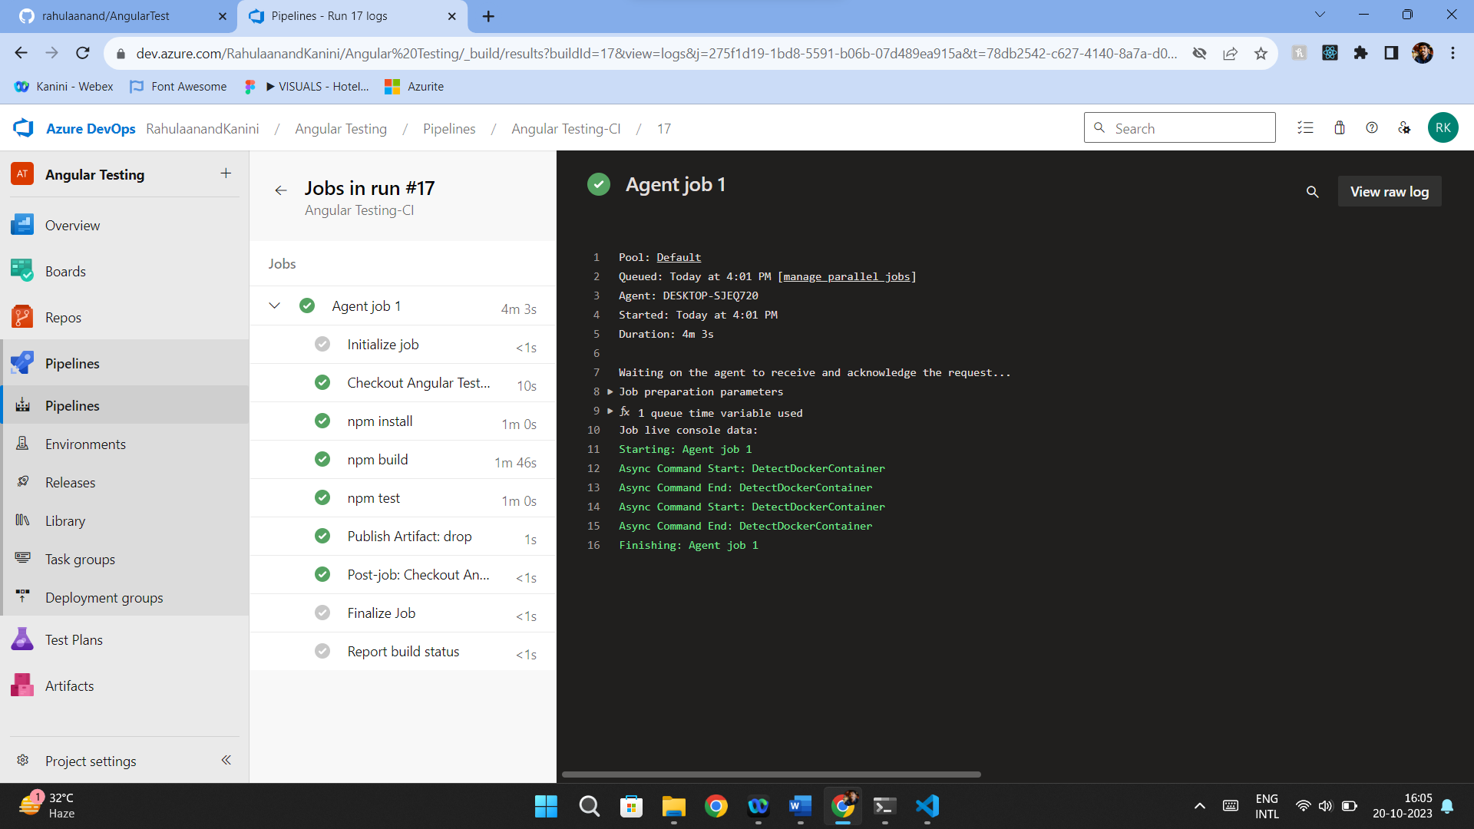

Lab 8: Create YAML Azure CI Pipeline for React Application

Objective: Create a YAML-based Azure CI pipeline to build a simple React application with unit testing using Enzyme and Jest.

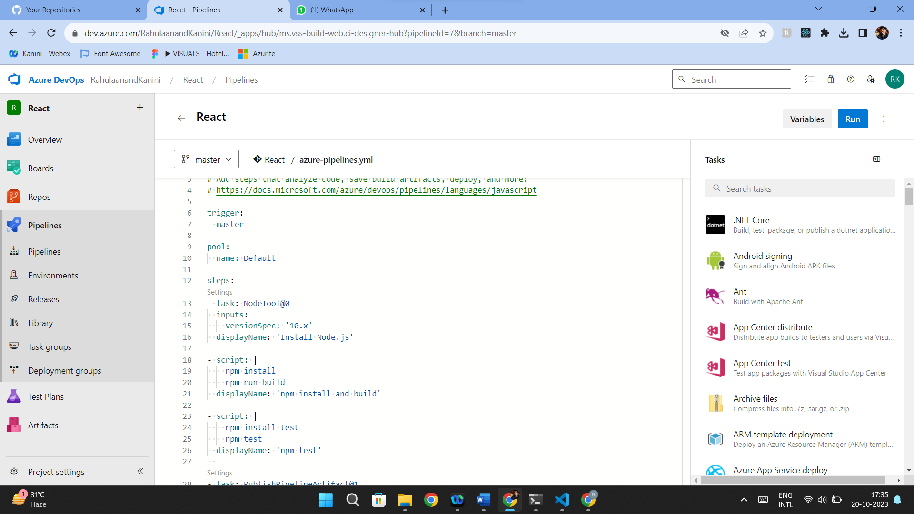

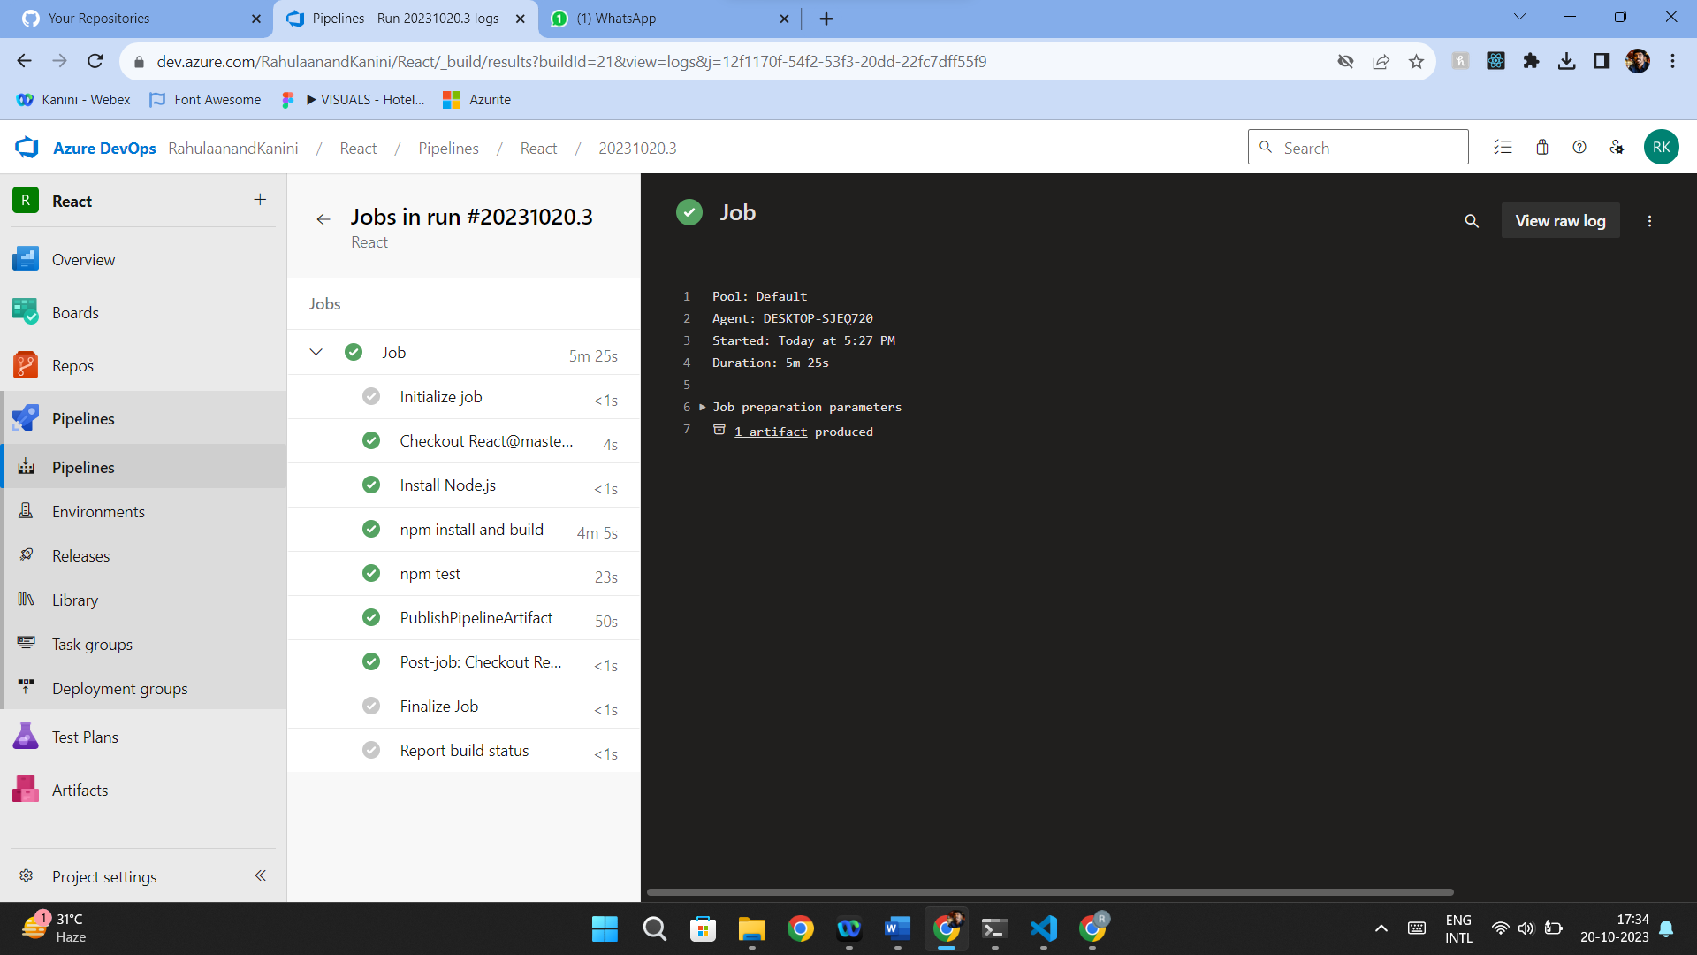

Lab 9: Create CI Pipeline for .NET Core Application with MS Unit Test

Objective: Create a CI pipeline, either classic or YAML, to build a .NET Core application and run MS Unit tests.  
  
